Eventora
A PROJECT REPORT
Submitted by
Nandini Kumari (26MCD10077)
in partial fulfillment for the award of the degree of
Masters of Computer Applications
IN

Data science



2026-28


Chandigarh University ·
[2026-28]

BONAFIDE CERTIFICATE

Certified that this project report titled "Eventora" is the bonafide work of Nandini Kumari (UID: 26MCD10077) who carried out the project work under my/our supervision in partial fulfillment of the requirements for the award of the degree of Master of Computer Applications at Chandigarh University.

SIGNATURE | SIGNATURE
Name: Nandini Kumari | Name: Ms. Tanisha
UID: 26MCD10077 | Designation: Assistant Professor
Class: MCD 2-A | E-Code: E2

ACKNOWLEDGEMENT

The successful completion of this project would not have been possible without the guidance, support, and encouragement of several individuals and organizations. It is a matter of great pleasure and privilege for me to express my sincere gratitude to all those who contributed directly or indirectly towards the completion of this project titled "Eventora."
First and foremost, I would like to express my heartfelt gratitude to [University Name] for providing me with the opportunity to undertake this project as a part of my academic curriculum. The university has provided an excellent learning environment, modern facilities, and valuable resources that helped me gain practical knowledge and technical skills throughout the course of this project.
I would like to convey my deepest appreciation to my project supervisor, [Supervisor Name], for constant guidance, constructive suggestions, and continuous motivation during every stage of the project. Their insights, technical expertise, and willingness to share knowledge played a crucial role in the successful completion of this work.
I am also thankful to the Head of the Department, faculty members, and staff of the Department of [Department Name] for their support and cooperation throughout the project duration. Their academic guidance and timely feedback helped me understand the practical applications of Java web development and database management systems.
Special thanks are extended to my friends and classmates who continuously encouraged me and shared valuable suggestions throughout the development process. Their discussions, feedback, and moral support helped me improve various aspects of the project and remain motivated during challenging phases of implementation.

TABLE OF CONTENTS
Chapter | Title | Section
Chapter 1 | Introduction | 1.0
 | Problem Statement & Client Identification | 1.1
 | Objectives of the Project | 1.2
 | Scope of the Project | 1.3
Chapter 2 | System Architecture & Design Flow | 2.0
 | System Architecture Overview | 2.1
 | Database Design & Entity Relationships | 2.2
 | Data Flow & System Flowcharts | 2.3
Chapter 3 | Implementation & Major Modules | 3.0
 | Backend Implementation (Java Servlets & DAO) | 3.1
 | Database Implementation (MySQL & JDBC) | 3.2
 | Frontend Integration (JSP) | 3.3
Chapter 4 | Project Showcase (Visual Walkthrough) | 4.0
 | Frontend Interfaces & User Experience | 4.1
 | Backend Validation & Routing | 4.2
 | DBMS Records & Schema Verification | 4.3
Chapter 5 | Testing & Validation | 5.0
 | Functional & Integration Testing | 5.1
 | Test Cases & Results | 5.2
Chapter 6 | Future Scope & Conclusion | 6.0
 | Proposed Enhancements | 6.1
 | Final Conclusion & References | 6.2

LIST OF FIGURE / TABLES

Type | Number | Title
Figure | 2.1 | System Architecture Diagram
Figure | 2.2 | Database Entity Relationship (ER) Diagram
Figure | 2.3 | Data Flow Diagram Level 1
Figure | 2.4 | Overall System Flowchart
Table | 5.1 | Functional Test Cases
Figure | 4.1 | Registration and Login Pages
Figure | 4.2 | Events Listing Page
Figure | 4.3 | Event Registration Confirmation & Error Messages
Figure | 4.4 | Student Dashboard (My Events)
Figure | 4.5 | Backend Console / Server Output
Figure | 4.6 | MySQL Workbench & DBMS Schema Records

Chapter 1: Introduction

1.1 Problem Statement & Client Identification
Eventora addresses the everyday challenge of organizing and participating in college events such as technical fests, workshops, seminars, cultural programs and sports meets. In most campuses, event announcements are scattered across notice boards, group chats and social media, and registrations are collected through paper forms or ad-hoc spreadsheets. This leads to duplicate entries, no reliable view of how many seats remain, over-booked events, and no easy way for a student to see which events they have signed up for.
The primary problem addressed is how to build a Java-based web application that centralizes event information, lets students register securely, enforces event capacity, prevents duplicate registrations, and gives every student a personal view of the events they have joined. The primary clients are the students of the institution, who use the portal to discover and register for events, and the event organizers or administrators, who benefit from accurate, real-time registration counts.

1.2 Objectives of the Project
The primary objective of Eventora is to provide a single, transparent platform for campus event discovery and registration, replacing manual and paper-based processes with structured digital records.
Functional objectives
- Provide secure student registration and login with session-based access control.
- Display all upcoming events with date, time, venue, category, capacity and live seat availability.
- Allow a logged-in student to register for an event with a single action.
- Enforce capacity limits and reject duplicate registrations.
- Provide a personal dashboard listing every event the student has registered for.
Technical objectives
- Demonstrate object-oriented programming in Java using a layered Model–DAO–Servlet design.
- Use Jakarta Servlets and JSP following the MVC pattern for request handling and presentation.
- Use JDBC with prepared statements for reliable, injection-safe access to a MySQL relational database.
- Apply session management, input validation and clean error reporting.

1.3 Scope of the Project
The functional scope covers student authentication (registration, login, logout), event listing with live registration counts, event registration with capacity and duplicate checks, and a personal dashboard of registered events. The technical scope is a Java (Jakarta Servlet/JSP) web application deployed on a servlet container such as Apache Tomcat, connected to a MySQL database named eventora_db through JDBC.

Chapter 2: System Architecture & Design Flow

2.1 System Architecture Overview
Eventora follows a layered MVC web-application architecture that separates presentation, request handling, business logic and data access. The browser renders JSP pages from /WEB-INF/views. Jakarta Servlets (LoginServlet, RegisterServlet, EventServlet, DashboardServlet) act as controllers: they validate the session, read request parameters, call the data layer and forward to the correct view. DAO classes (StudentDAO, EventDAO) hold all SQL and talk to the MySQL database through JDBC, using the DBConnection utility. Model classes (Student, Event) carry data between the layers.
Layer | Package | Classes | Responsibility
Presentation | /WEB-INF/views | login.jsp, register.jsp, events.jsp, dashboard.jsp | Render pages, show messages
Controller | com.eventora.servlet | LoginServlet, RegisterServlet, EventServlet, DashboardServlet | Routing, session checks, validation
Model | com.eventora.model | Student, Event | Data holders plus helper logic (slots left, fill percent)
Data access | com.eventora.dao | StudentDAO, EventDAO | SQL queries and mapping rows to objects
Utility | com.eventora.util | DBConnection | Open and close JDBC resources
Database | MySQL eventora_db | students, events, registrations | Persistent storage

2.2 Database Design & Entity Relationships
The relational design uses three tables. The students table stores account details. The events table stores event information and the seat capacity. The registrations table links a student to an event (a many-to-many relationship), so one student can join many events and one event can have many students. Foreign keys enforce referential integrity: a registration cannot refer to a student or event that does not exist, and a uniqueness rule on the student–event pair prevents the same student registering twice for the same event.
STUDENTS
Column | Type | Notes
student_id | INT | Primary key
full_name | VARCHAR | Student name
email | VARCHAR | Unique, used for login
password | VARCHAR | Login password
roll_number | VARCHAR | Stored in upper case
department | VARCHAR | Student department
phone | VARCHAR | Optional
created_at | TIMESTAMP | Account creation time

EVENTS
Column | Type | Notes
event_id | INT | Primary key
title | VARCHAR | Event name
description | TEXT | Event details
category | VARCHAR | e.g. Technical, Cultural, Sports
event_date | DATE | Date of event
event_time | TIME | Start time
venue | VARCHAR | Location
capacity | INT | Maximum seats
created_at | TIMESTAMP | Record creation time

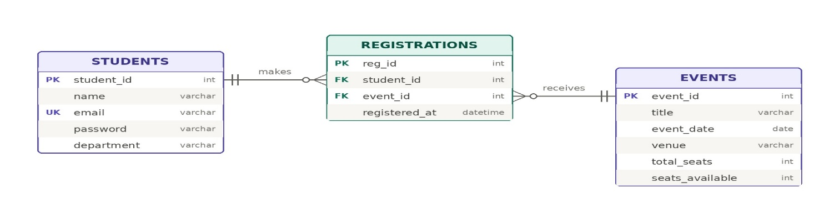
REGISTRATIONS
Column | Type | Notes
registration_id | INT | Primary key
student_id | INT | Foreign key to students
event_id | INT | Foreign key to events

Figure 2.1 — Database Entity Relationship (ER)

2.3 Data Flow & System Flowcharts
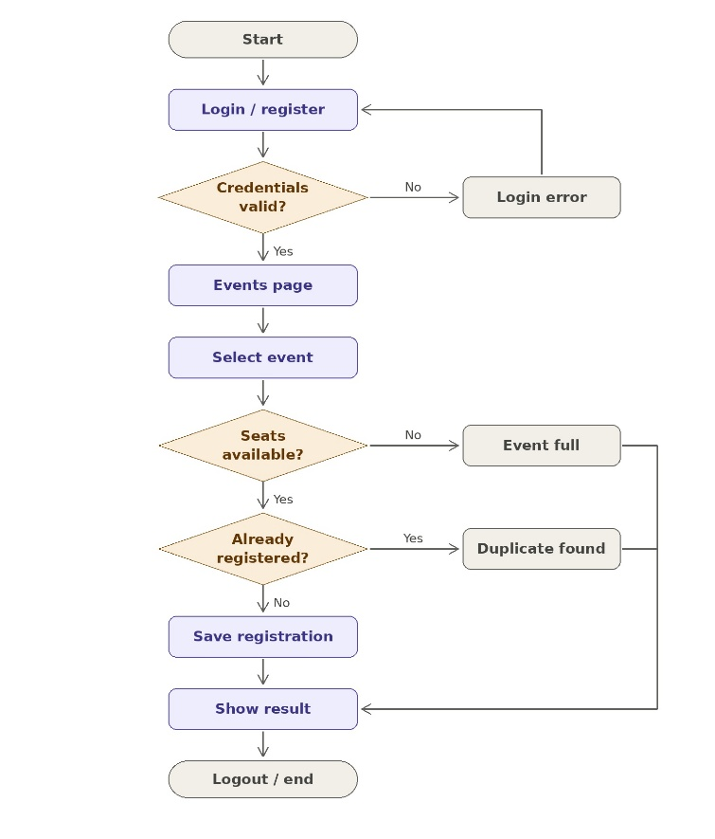
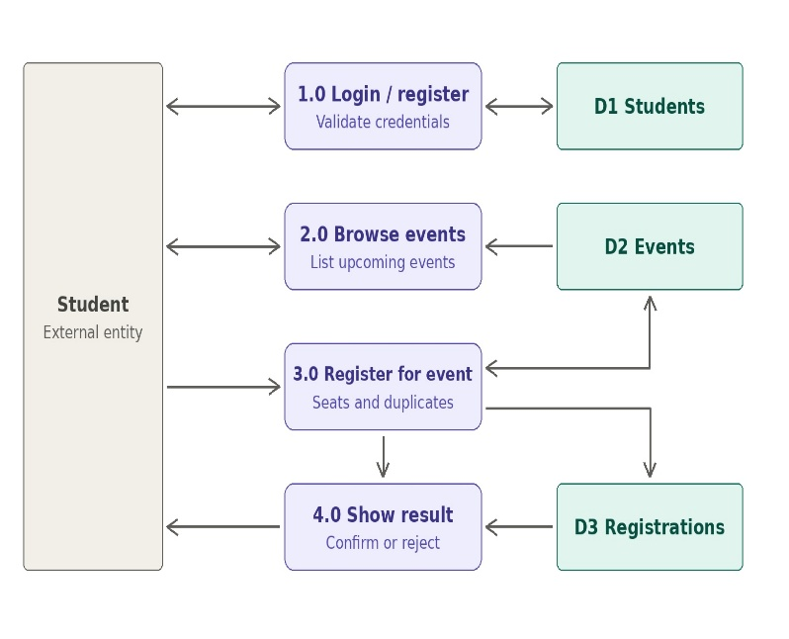
At Level 0, the student provides credentials and event choices and receives event listings, registration results and a personal dashboard in return. Level 1 breaks this into four processes: User Access (registration, login, logout), Event Listing, Event Registration, and Dashboard. Each registration request is checked in order: valid session, event exists, seats available, then insert, with the database rejecting a duplicate student–event pair. The outcome (success, full, duplicate or error) is returned to the events page as a message.
Figure 2.2 — Data Flow Diagram Level 1

Figure 2.3— Overall System Flowchart

Chapter 3: Implementation & Major Modules

3.1 Backend Implementation (Java Servlets & DAO)
The backend is organized into packages that separate controllers, models, data access and utilities. Servlets are mapped to URLs with the @WebServlet annotation.
Servlet | URL mapping | Function
RegisterServlet | /register | Shows the sign-up form; validates that all fields are filled, passwords match and the email is unused; saves the student; redirects to login
LoginServlet | /login, /logout | Authenticates by email and password, creates the session (30-minute timeout); on logout, invalidates the session and expires the JSESSIONID cookie
EventServlet | /events, /events/register | GET lists all events and marks the ones the student already joined; POST registers the student and redirects back with a result message
DashboardServlet | /dashboard | Lists the events the logged-in student has registered for

Session handling. After a successful login, the Student object is stored in the HTTP session. Every protected servlet checks the session first and redirects to /login when no student is present. The student ID used for registration is taken from the session, never from the form, so a user cannot register on behalf of someone else.
Registration logic (EventDAO.register). The method loads the event with its current registration count and returns one of four results: error if the event does not exist, full if no seats remain, success after a successful insert, and duplicate when the database reports an integrity-constraint violation for the same student and event.
Model helpers. The Event class calculates hasSlotsAvailable(), getSlotsLeft() and getFillPercent(), which the view uses to show remaining seats and a progress bar. The Student class is a plain data holder.

3.2 Database Implementation (MySQL & JDBC)
Eventora stores its data in a MySQL database named eventora_db. The DBConnection utility loads the MySQL JDBC driver and returns a connection, and its close(...) method safely releases connections, statements and result sets. All data access uses PreparedStatement with bound parameters, which protects against SQL injection and keeps queries readable.
Events are always fetched together with their live registration count using a LEFT JOIN on the registrations table with COUNT and GROUP BY, so the seat count is computed by the database and is never stored separately. A student's own events are fetched with an INNER JOIN filtered on the student ID.

3.3 Frontend Integration (JSP)
The frontend consists of JSP views stored under /WEB-INF/views, which keeps them from being opened directly in a browser and forces every page to be reached through a servlet. Servlets pass data to the views as request attributes (for example events, student, myEvents and a per-event registered flag), and the views render it with HTML, CSS and JavaScript. Errors such as an invalid login or mismatched passwords are set as an error attribute and displayed on the same form, and registration outcomes are carried in the msg query parameter after a redirect, which prevents a duplicate form submission when the page is refreshed.

Chapter 4: Project Showcase (Visual Walkthrough)
This chapter gives a visual demonstration of the completed Eventora application, showing how the browser interface, the server-side logic and the stored database records work together.

4.1 Frontend Interfaces & User Experience
The interface is designed so that forms are clear, navigation is simple and event details such as date, venue and remaining seats are easy to read.
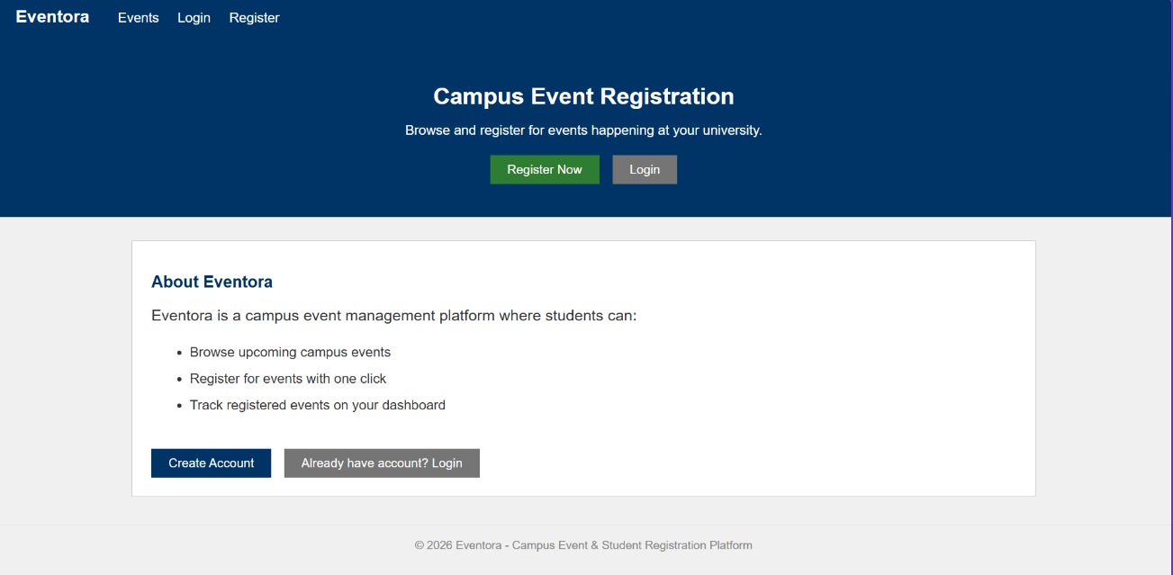

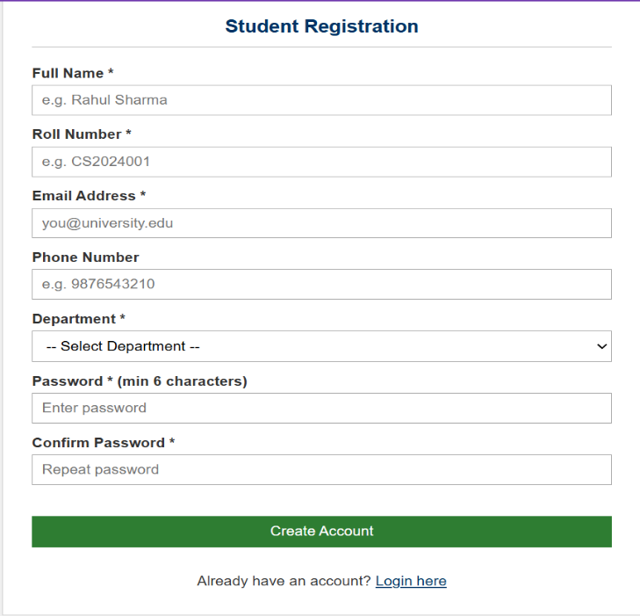
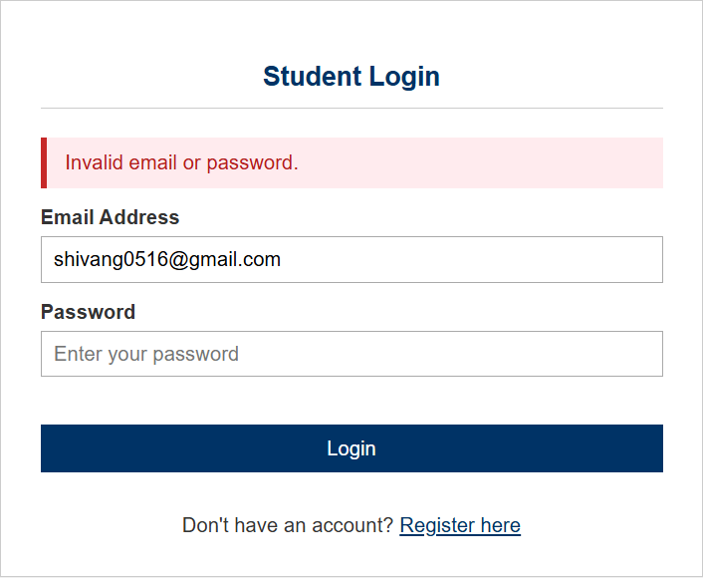
Figure 4.2: Registration Page

Figure 4.1: Login Page
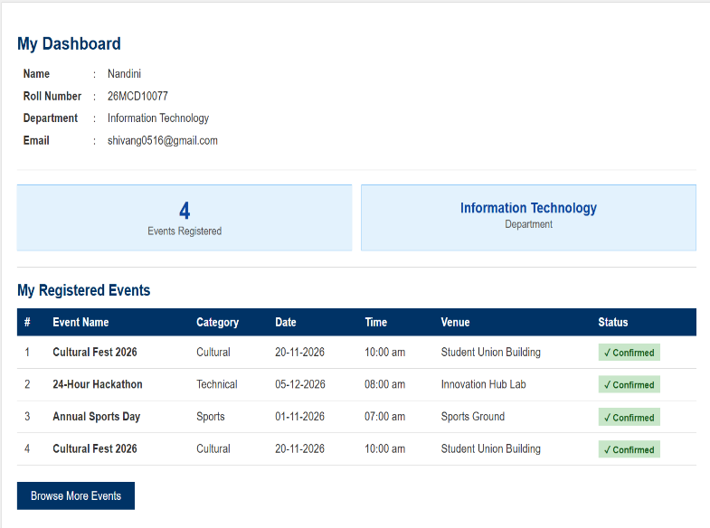
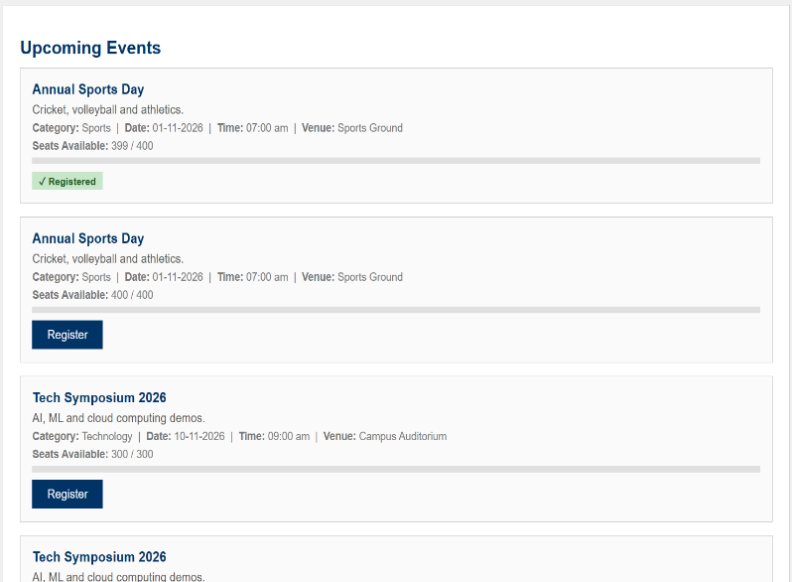
Figure 4.3: Events Listing Page

Figure 4.4: Student Dashboard (My Registered Events)

4.2 Backend Validation & Routing
The backend validates input before any data is saved: empty fields, mismatched passwords and already-registered emails are rejected with an error message, and unauthenticated requests are redirected to the login page.
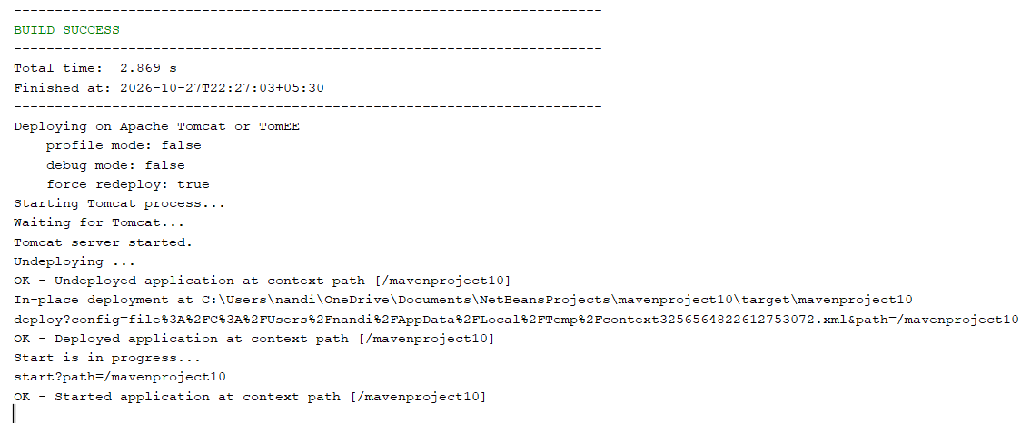
Figure 4.5: IDE / Tomcat Server Console Output

4.3 DBMS Records & Schema Verification
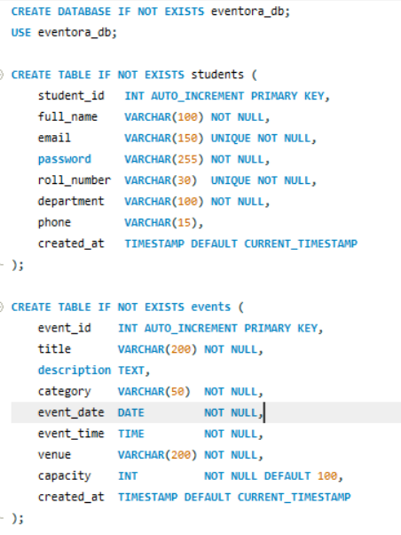
To show that data is persisted, the actions performed in the interface are verified directly in the MySQL tables.
Figure 4.6: MySQL Workbench

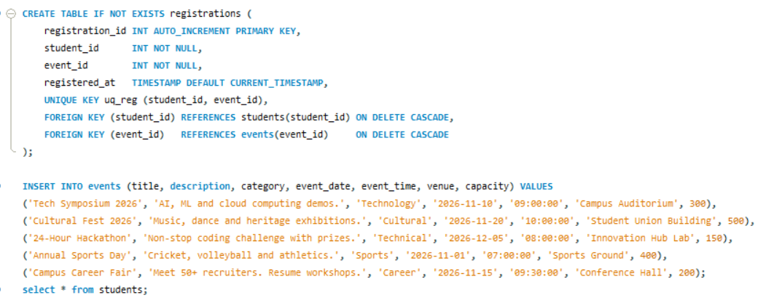
Figure 4.5: MySQL Workbench Tables

Chapter 5: Testing & Validation

5.1 Functional & Integration Testing
Testing verifies that the servlets, DAO classes, database and JSP views work together. Functional testing checks that each feature (registration, login, event registration, dashboard) behaves as specified. Integration testing confirms that data entered in the browser reaches the MySQL tables correctly and that results are displayed back without broken routes or missing pages.

5.2 Test Cases & Results
The system was checked against the following functional test cases. Fill in the Status column after running each test.
Test Case ID | Module | Description | Expected Result | Status
TC-01 | User Access | Register a new student with valid details | Record created in students; redirected to login | [Pass / Fail]
TC-02 | User Access | Register with an already-used email | Error "Email already registered." shown | [Pass / Fail]
TC-03 | User Access | Register with mismatched passwords | Error "Passwords do not match." shown | [Pass / Fail]
TC-04 | User Access | Login with correct email and password | Session created; redirected to events page | [Pass / Fail]
TC-05 | User Access | Login with incorrect password | Access denied; "Invalid email or password." shown | [Pass / Fail]
TC-06 | Session Security | Open /events or /dashboard without logging in | Redirected to login page | [Pass / Fail]
TC-07 | Event Listing | Open the events page after login | All events shown with date, venue, capacity and slots left | [Pass / Fail]
TC-08 | Event Registration | Register for an event with free seats | Row added to registrations; success message; seat count increases | [Pass / Fail]
TC-09 | Event Registration | Register for the same event again | Duplicate registration rejected with message | [Pass / Fail]
TC-10 | Event Registration | Register for an event that has reached capacity | Registration rejected with "full" message | [Pass / Fail]
TC-11 | Dashboard | Open dashboard after registering | Registered events listed with correct counts | [Pass / Fail]
TC-12 | Logout | Click logout, then press browser Back | Session ended; protected pages redirect to login | [Pass / Fail]

A key validation rule is that the number of registrations for an event never exceeds its capacity and that the same student cannot hold two registrations for one event. The capacity rule is checked in the application before the insert, and the duplicate rule is enforced by the database and reported to the student as a "duplicate" result.

Chapter 6: Future Scope & Conclusion

6.1 Proposed Enhancements
While Eventora successfully handles student registration and event sign-up, the layered design allows easy extension. Proposed future work includes:
- Administrator Panel: Allow organizers to create, edit and cancel events and to view or export the list of registered students.
- Unregister / Cancel Registration: Let students withdraw from an event and free up a seat.
- Atomic Seat Booking: Perform the capacity check and insert in a single database transaction (or with a conditional insert) so that simultaneous registrations can never exceed capacity.
- Notifications: Send e-mail or SMS confirmations and reminders before the event date.
- Search and Filters: Search events by title, category or date, and hide events that are already over.
- QR-Code Check-in and Certificates: Generate a QR pass per registration for attendance marking and issue participation certificates.
- Production Security: Replace plain-text password storage with salted hashing (for example BCrypt), add CSRF protection, move database credentials out of source code into configuration, use a connection pool, and deploy over HTTPS in a cloud-hosted environment.

6.2 Final Conclusion & References
Eventora successfully demonstrates the translation of a common campus problem, scattered and manual event registration, into a structured, database-driven web application. By combining Java Servlets and JSP with a layered Model–DAO design and a MySQL database, the project replaces paper forms and spreadsheets with a centralized, transparent and real-time registration system. The application meets its core academic objectives by showing object-oriented design, MVC request handling, session management, safe JDBC access with prepared statements and relational data persistence. Eventora provides a solid foundation for a full campus event-management platform.
References
- Eclipse Foundation, Jakarta Servlet Specification. https://jakarta.ee/specifications/servlet/
- Eclipse Foundation, Jakarta Server Pages Specification. https://jakarta.ee/specifications/pages/
- Oracle, MySQL Reference Manual. https://dev.mysql.com/doc/
- Oracle, JDBC Basics (The Java Tutorials). https://docs.oracle.com/javase/tutorial/jdbc/
- Apache Software Foundation, Apache Tomcat Documentation. https://tomcat.apache.org/
- Project source code: https://github.com/nandiniitech/eventora

